ADVANCED JAVA PPROGRAMMING

SEMINAR

TEAM-3

9. Design and implement a simple Client Server Application using RMI.

STEPS INVOLVED:

* Define the remote interface.
* Develop the implementation class (remote object)
* Develop the server program.
* Develop the client program.
* Compile the application.
* Execute the application.

SOFTWARE REQUIRED:

* 1. JAVA
  2. COMMAND PROMPT

CODES:

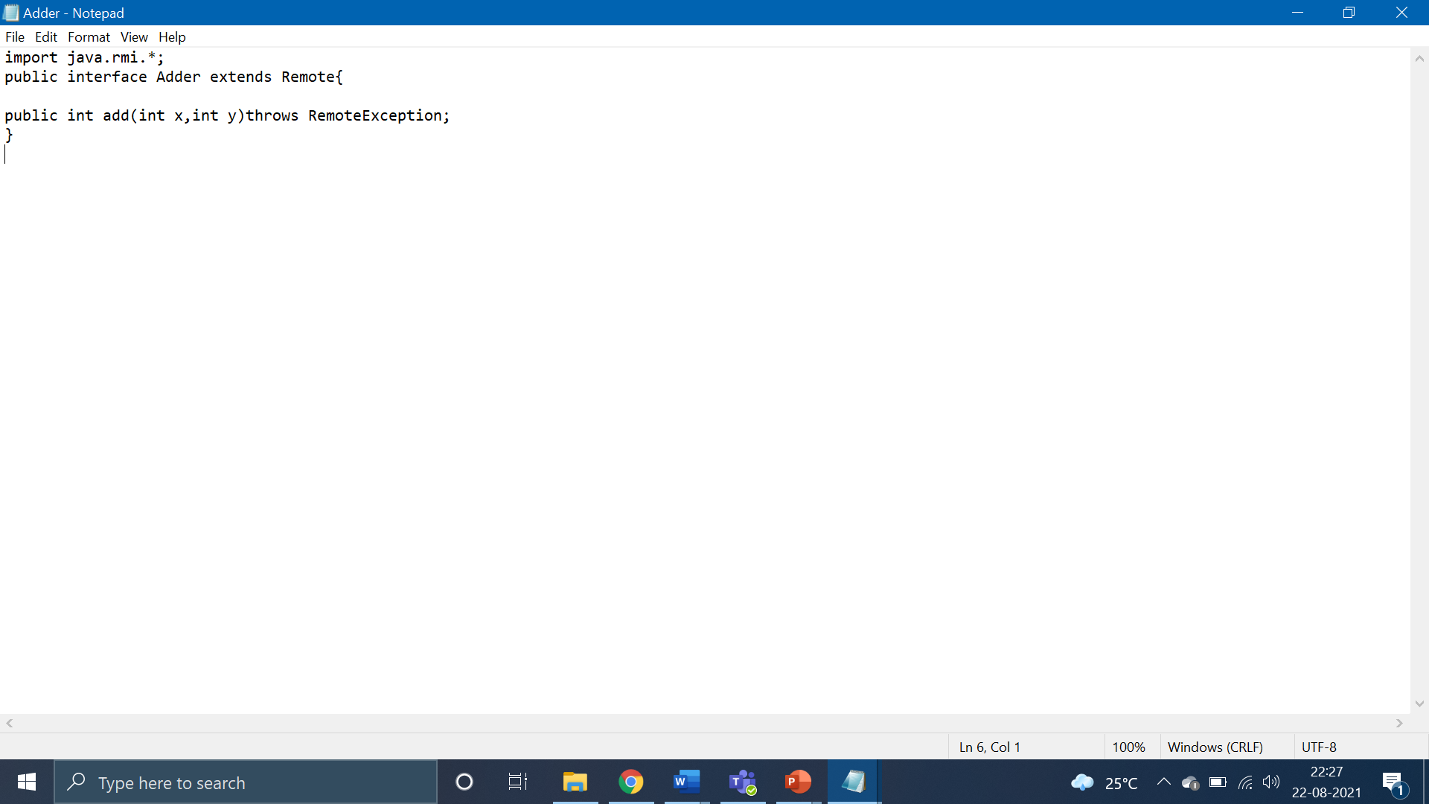

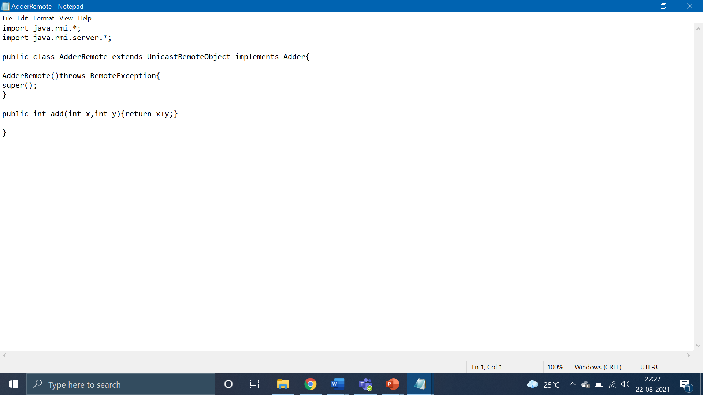

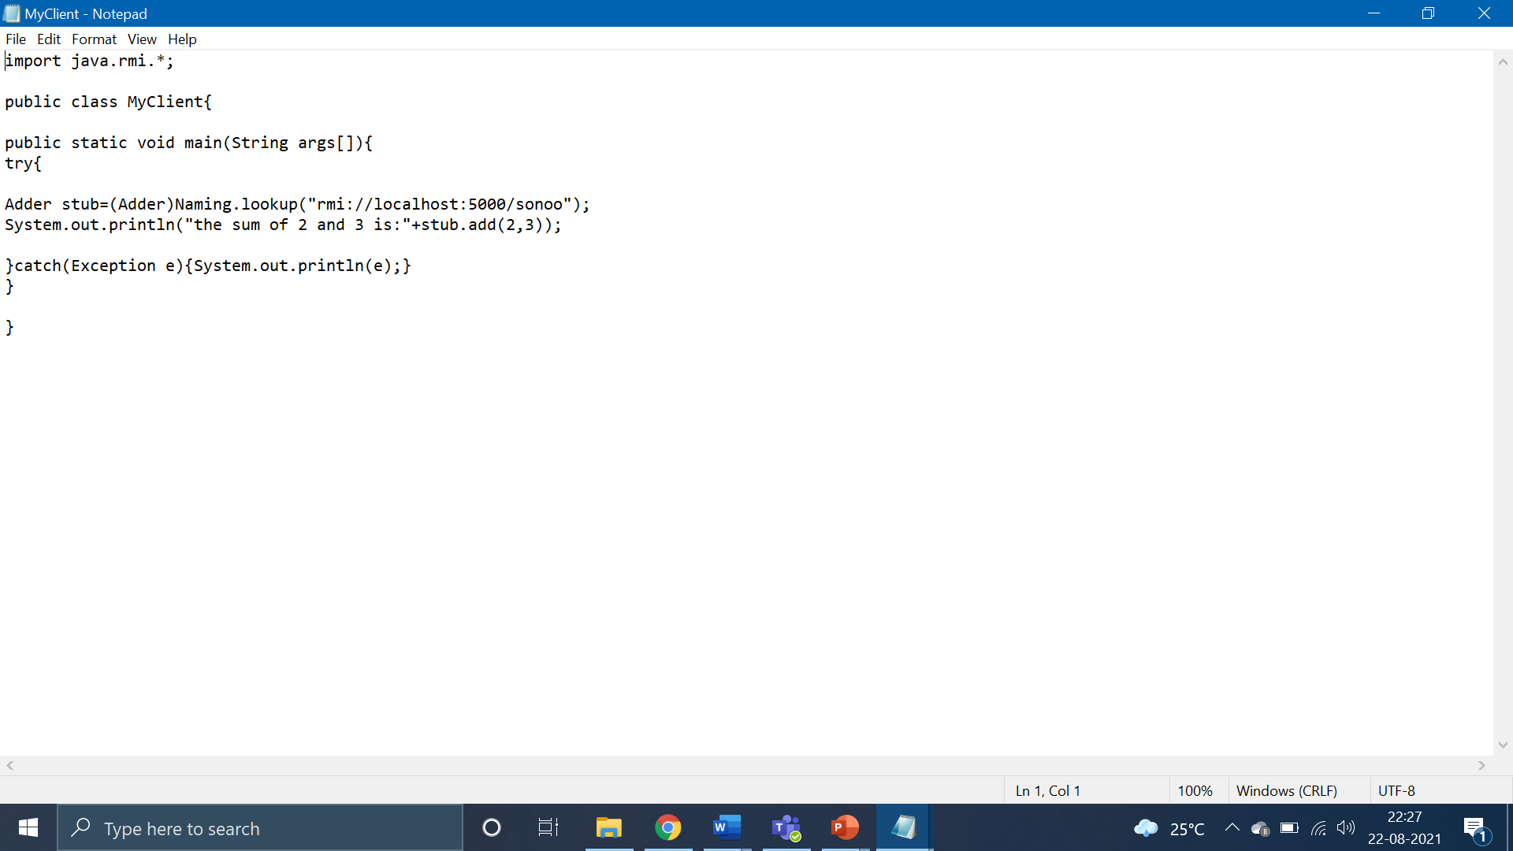

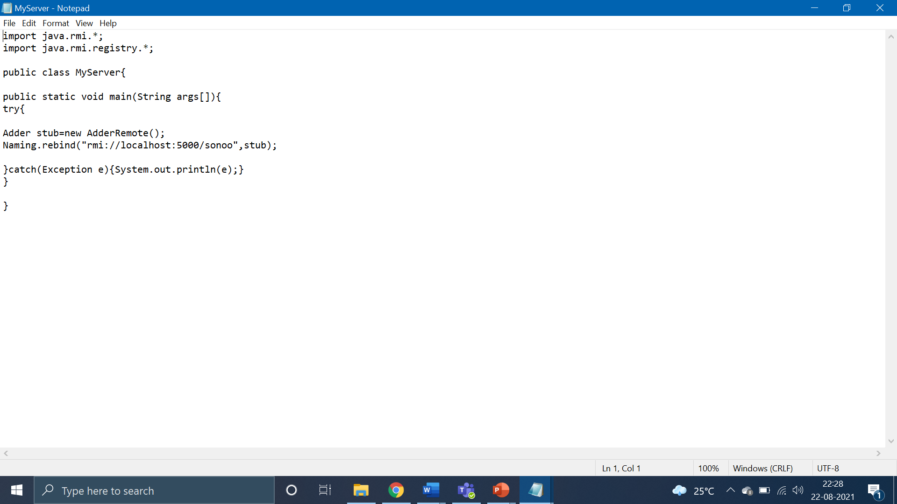

OUTPUT:

